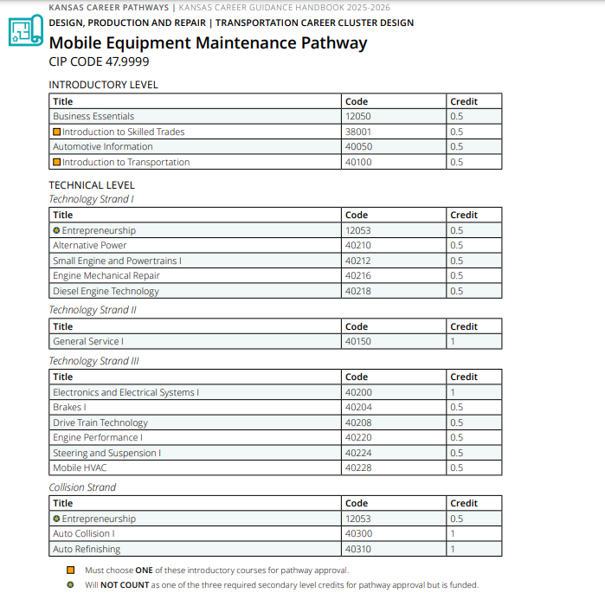
Prior to the Cluster Review

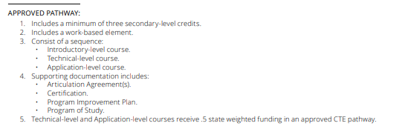

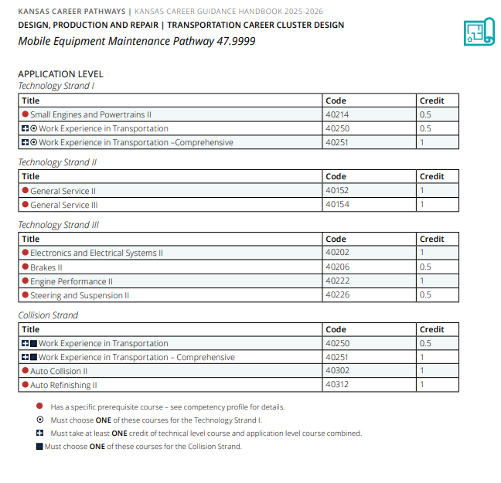

Recommendations Following Cluster Review


DESIGN, PRODUCTION AND REPAIR | TRANSPORTATION CAREER CLUSTER DESIGN

Vehicle Mobile Equipment Maintenance & Repair Pathway

CIP CODE 47.9999 47.0600
INTRODUCTORY LEVEL
Title | Code | Credit
Business Essentials | 12050 | 0.5
Introduction to Skilled Trades | 38001 | 0.5
Basic Automotive Care & Information | 40050 | 0.5
Introduction to Transportation | 40100 | 0.5
TECHNICAL LEVEL
Title | Code | Credit
General Service I | 40150 | 1
Electronics and Electrical Systems I | 40200 | 1
Brakes I | 40204 | 0.5
Drive Train Technology | 40208 | 0.5
Diesel & Heavy Equipment Engine Technology | 40218 | 0.5 1
Engine Performance I | 40220 | 0.5
Steering and Suspension I | 40224 | 0.5
Mobile HVAC | 40228 | 0.5
Auto Collision I | 40300 | 1
Auto Refinishing | 40310 | 1
OPTIONAL SUPPORT COURSES
Title | Code | Credit
Entrepreneurship | 12053 | 0.5
Alternative Power | 40210 | 0.5
Small Engine and Powertrains I | 40212 | 0.5
Engine Mechanical Repair | 40216 | 0.5
Must choose ONE of these introductory courses for pathway approval.
- Will NOT COUNT as one of the three required secondary level credits for pathway approval but is funded.
- Optional Support Courses are available after having enough credits for pathway approval.


DESIGN, PRODUCTION AND REPAIR | TRANSPORTATION CAREER CLUSTER DESIGN
Vehicle Mobile Equipment Maintenance & Repair Pathway 47.9999 47.0600

APPLICATION LEVEL
Title | Code | Credit
General Service II | 40152 | 1
General Service III | 40154 | 1
Electronics and Electrical Systems II | 40202 | 1
Brakes II | 40206 | 0.5
Engine Performance II | 40222 | 1
Steering and Suspension II | 40226 | 0.5
Diesel & Heavy Equipment Engine Technology II | 40238 | 1
Diesel & Heavy Equipment Engine Technology III | 40239 | 1
CDL – Entry Level Driver Prep | 40240 | 0.5
Auto Collision II | 40302 | 1
Auto Refinishing II | 40312 | 1
Work Experience in Transportation | 40250 | 0.5
Work Experience in Transportation - Comprehensive | 40251 | 1

OPTIONAL SUPPORT COURSE
Title | Code | Credit
Small Engines and Powertrains II | 40214 | 0.5
Has a specific prerequisite course – see competency profile for details.
- Must choose one of these for Pathway Approval and must take ONE credit of technical level course and application-level course combined.
Optional Support Courses are available after having enough credits for pathway approval

Pathway Recommendations Summary:
CTE Course Competencies and Indicators (ksde.org)
No Recommend Changes
- Courses not reviewed by this committee.
  - 12050 Business Essentials
  - 12053 Entrepreneurship
  - 38001 Introduction to Skilled Trades
- Courses Reviewed with no changes.

  - 40150 General Service I
  - 40200 Electronics and Electrical Systems
  - 40202 Electronics and Electrical Systems II
  - 40152 General Service II
  - 40154 General Service III
  - 40210 Alternative Power
  - 40224 Steering & Suspension I
  - 40226 Steering & Suspension II
  - 40250 Work Experience in Transportation
  - 40251 Work Experience in Transportation – Comprehensive
  - 40300 Auto Collision I
  - 40302 Auto Collision II
  - 40312 Auto Refinishing II
Courses Reviewed with Recommended Changes
- Courses being removed from the pathway.
  - 40100 Introduction to Transportation
- Courses with updated competencies and benchmarks
  - 40050 Basic Automotive Care & Information
  - 40204 Brakes I
  - 40206 Brake II
  - 40208 Drive Train Technology
  - 40212 Small Engine & Powertrains I
  - 40214 Small Engine & Powertrains II
  - 40216 Engine Mechanical Repair
  - 40218 Diesel Engine & Heavy Equipment Technology
  - 40220 Engine Performance I
  - 40222 Engine Performance II
  - 40228 Mobile HVAC
  - 40310 Auto Refinishing I
New Course Recommendations
- Courses Recommended to be Added.
  - 40238 Diesel Engine & Heavy Equipment Technology II
  - 40239 Diesel Engine & Heavy Equipment Technology III
  - 40240 CDL – Entry Level Driver Training

